Request for Design Proposals
Mosaic Design on Smither Park Wall

Mission
WiVLA has secured a space on the wall at Smither Park for WiVLA members to construct a mosaic design that identifies our organization and mission.

Site Specifications
Ours is the second space to the right of the large white mosaic that is located in the center of the wall. Following deconstruction of the former design in our space, WiVLA members will construct a new design from the available ceramic tiles, pottery, mortar, and other materials. The Orange Show provides an extensive supply of materials in a warehouse that is located on the property. We can implement a design from this supply or we can augment it with materials of our own.
The following image shows the location of WiVLA’s space, relative to the large white mosaic.
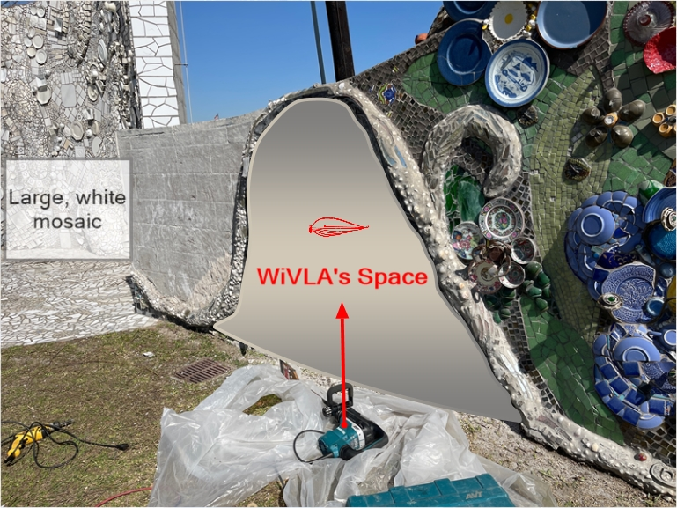
WiVLA’s portion of the wall is bounded by a mosaic region that winds throughout the wall, separating the sections. WiVLA’s section is approximately 67” high, 45” wide at the midpoint, and 90” at the base.
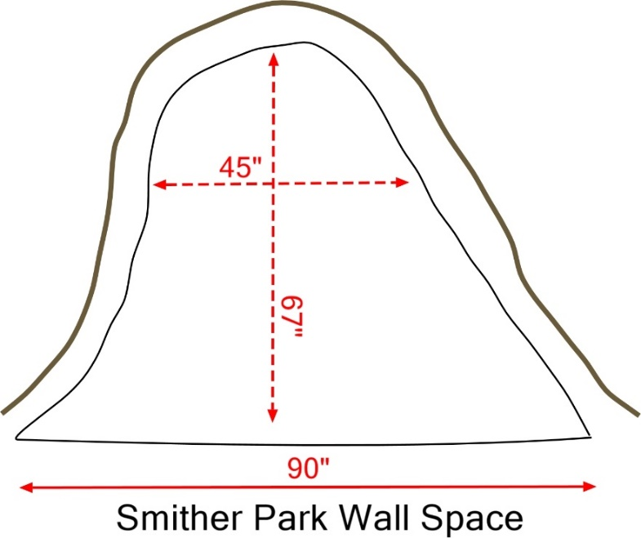

Design Content
The mosaic design must readily represent WiVLA and its mission by using as few words as possible. Because it is public art in a park, it cannot contain offensive or political representation.

Design Submission
When designing the wall mosaic, use the pattern provided on the last page of this document as the base for the design.
- To help describe some of the types of tiles or other materials that you will use, take photos of representative samples already present on the wall.
- When submitting a design proposal, photograph your design.
- Email the design image, along with supporting documentation and images that will adequately describe your design and materials, to info@wivla.org. Be sure the put Smither Park Wall in the subject line.

Deadline for Submission
All submissions must be received by 11:59 p.m. on Sunday, May 1, 2022.

Design Selection
The WiVLA Board will select two finalists from the submissions, and the membership will vote for the final design. The decision of the membership will be final, pending approval of the Orange Show. The accepted wall design will be constructed by WiVLA members and WiVLA reserves the right to use its likeness in any promotional materials, including the website. WiVLA will attribute the design to winning designers on the website and other channels and materials.

Design Template

